Physics 256 Assignment 6 Solution 2012
diagrams to scale

Total marks 72

- 4 marks For an incident angle of 30 deg below the normal on a prism with apical angle of 50 deg and n=1.5, trace the refraction through the prism (including the angles of incidence and refraction at each surface) and calculate the angle of deviation.

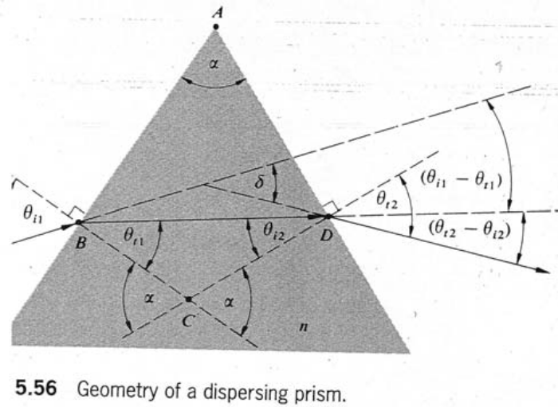Diagram not needed
n sin θt1 = sin θi1
sin θt1= sin θi1/n
θt1 =19.5 deg (OR 19deg)
α= θt1 + θi2
θi2=α-θt1=50-19.5=30.5 (OR 30 deg)
sin θt2 = nsin θi2
θt2=49.6 (OR 50 deg)
δ = θi1 +θt2 - α =30+49.6-50=29.6 deg (OR 30 deg)

- a) For a prism with a 30 deg apical angle and with n=1.6, calculate the incident ray angle for which the minimum angle of deviation occurs.3 marks
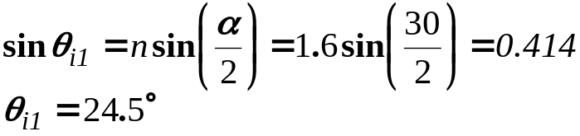
What is the minimum angle of deviation? 3 marks

OR

Students also get full marks if they solve this for n=1.5
b) 3 marks If we create a prism of unknown material with a known apical angle of 30 deg and the minimum angle of deviation of light is 16 deg, what is the refractive index of the material for the incident wavelength?
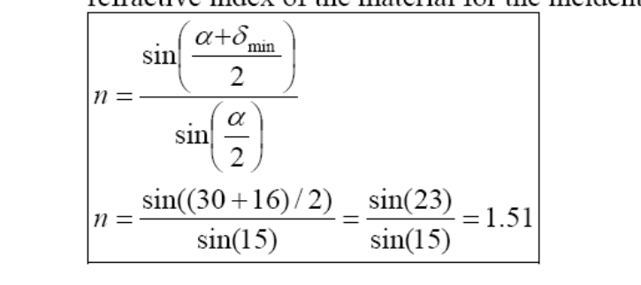

3) 2 marks What is the thin prism deviation for a glass prism with a 4 deg apical angle and n=1.5?
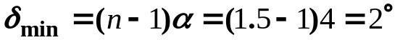
b) 2 marks If highlite glass (n=1.7) is used with the same apex, what is the angle of deviation?
Correct answer also for n=1.8, δ_{min}=4.8° OR 5°

4) 4 marks A prism has a refractive index of 1.62 for red light and 1.64 for blue light. For an apical angle of 30deg, determine the minimum angular deviation for each of the colours and their angular spread. Angular spread is the difference in angle between the two exiting rays.
For the minimum angle of deviation: Red light: sinθ_{i1}=nsin(α/2)=1.62*sin15°=0.419; θ_{i1}=24.8°; δ_{min}=2 θ_{i1}- α=19.6°
Blue light: sinθ_{i2}=nsin(α/2)=1.64*sin15°=0.424; θ_{i1}=25.1°; δ_{min}=2 θ_{i1}- α=20.2°
Angular spread=20.2°-19.6°=0.6°
b) 3 marks Now use the approximation for a small apical angle.

Red light: δ_{min}=(n-1)α=18.6°
Blue light: δ_{min}=(n-1)α=19.2°
Angular spread=19.2°-18.6°=0.6°
Note that the small angle approximation doesn’t apply for each ray’s deviation but does apply to the small difference between them.

5) 4 marks a) I am 5 ft 2 in tall with my eyes 5 ft from the floor. I am looking into a vertical mirror. How far above the floor can the bottom edge of the mirror be and I can still see the image of my foot? Hint: draw a ray which must enter the eye and come from the foot. Then figure out how this ray changes as it height on the mirror changes. 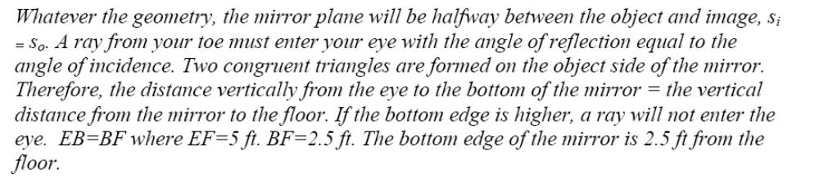
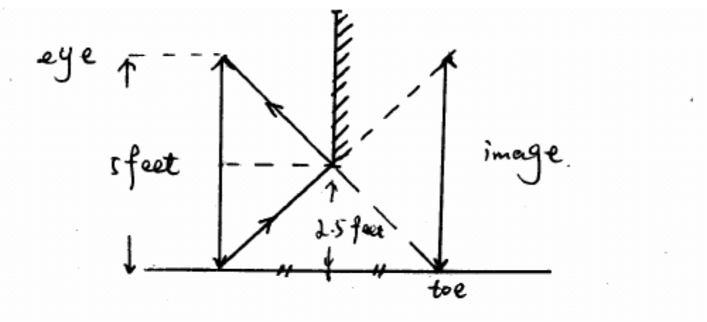
4 marks b) In a) above, sketch a ray from my toe, seen by me and sketch the vertical image of my body in the mirror.
In a) congruent triangles FAB and EAB are because the three angles are equal to each other and 1 side is shared. Extra explanation
F

B
A

E

6) 7 marks Two mirrors: 4.8. Reflect the ray from both mirrors. I have posted a construction of images seen in two mirrors.
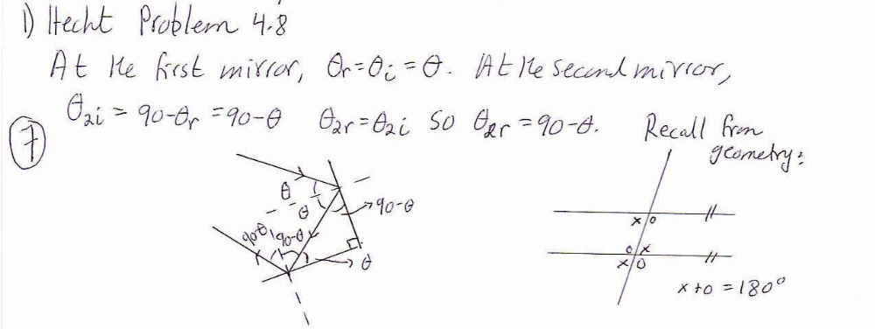

If the angle is 90-θ to the second normal, and the normals are at 90 deg, the ray forms an angle of θ to the first normal (angles of the triangle of the 2 normals and the exiting ray add to 180 deg). Therefore the final ray is parallel to the incoming beam and travelling in the opposite direction. OR you can use the fact that the angles either side of the intermediate ray are both equal to 2θ and the intermediate ray joins the initial and final rays together. No need to show more angles than minimum necessary to proof.
7) 5.48b) Two mirrors Look at the image formed by each mirror and the image that will be formed from light that reflects from both mirrors. 6 marks for the images. Draw at least 1 sample ray for each of the 3 images formed. 6 marks for the rays. TOTAL 12 marks labels on mirrors, object and images are not necessary
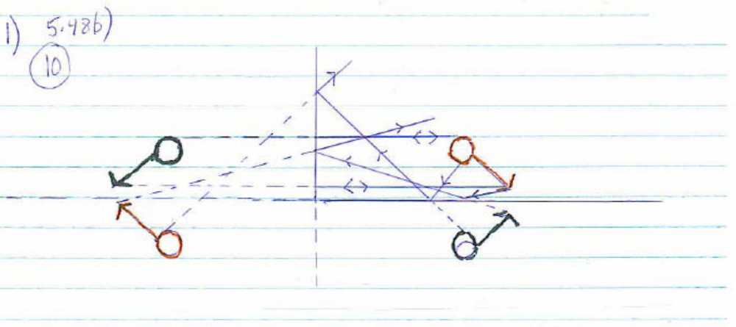
object
Image from m1
M1
M2
Image from m2
Image from m1, then m2
8) 6 marks Spherical mirror: 5.53 Quantify the magnification, say whether it is upright or inverted and real or virtual image.
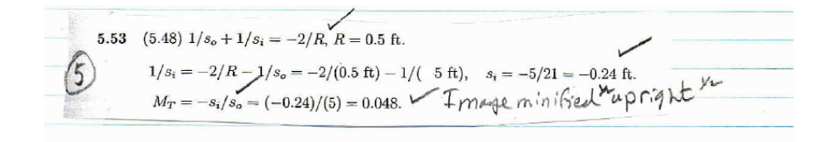
Virtual^{1/2}

9) Spherical mirror 5.58. The ray diagram should have the object, image, mirror and at least 2 rays. 15 marks
